CAISTOR
Neighbourhood Policing Team

YOUR LOCAL TEAM
MarketRasenandWelton@lincs.police.uk
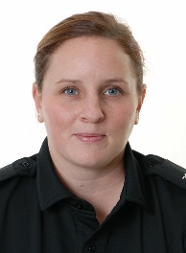
PC Gemma Bailey | PCSO Dawn Cowling

FORTHCOMING ENGAGEMENTS
Police Surgeries – No appointment necessary
Keelby Library
Wednesday 15th February 3pm-4pm
Caistor Co-op
Friday 17th February 12-1pm
Caistor Police Station
Wednesday 15th February 1-2pm
Wednesday 22nd February 3-4pm
Brookenby - see café notice board for details
Claxby Village Hall
Awaiting confirmation of dates – please contact parish council for details.
Unforeseen circumstances may alter these times – please email us and we will contact you.

LOCAL PRIORITY
Every three months, we listen to your concerns and look at recent crime statistics to shape the things we will concentrate on for the next three months. Our priority(s) for the next quarter is:
Vehicle Anti-social Behaviour
WHAT’S BEEN HAPPENING
Search:Gainsborough Police
We continue to monitor vehicle asb in our area and welcome any information.
We have been working with Caistor Primary school to reduce vehicle problems near the school.
Due to the continual reports of scams of various kinds, Caistor NPT will be holding a presentation on Thursday 16th February 2023 11-12pm and Friday 24th February 1-2pm at Caistor Town Hall, detailing new scams, what to do if you are scammed and also information about your neighbourhood policing team.
If you experience problems with door to door sales people, please ring 101 and do not feel obliged to open your door to anyone that you are not expecting.

